Project Proposal – Team o8o

Design Your Code

: Designer Helper

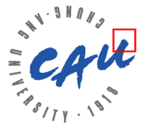

Team: o8o

구동완, 김민지, 최현준

목차

**Project Overview and Motivation1**

**Project Objective2**

**User case2**

**Development environment and implement3**

Development Environment3

Implement Features3

Project Problems4

**Task Assignment / Project Schedule5**

Task Assignment5

Task Schedule5

**Summary7**

1. **Project Overview and Motivation**

Lower Learning curve – Immediate Use

Many junior developers, even the software major students, feel nervous when they learn the new computer language. Sometimes, there’s no one to help them when they learn, or they have some difficulties to find function which they want.

Especially, designer’s burden about computer language and communication with developer can be grown up in the tight development schedule of the startup, which must show prototype results quickly and accurately.

Based on these problems, we devise a ‘Design Your Code : designer helper’ which can help the junior coder and designer especially the 3D graphic designer who covers program like C4D(Cinema 4D) using Python, to do more easier works using Block coding like Scratch. Also, it will help communication between designer and developer by adding a function that changes the design result to code.

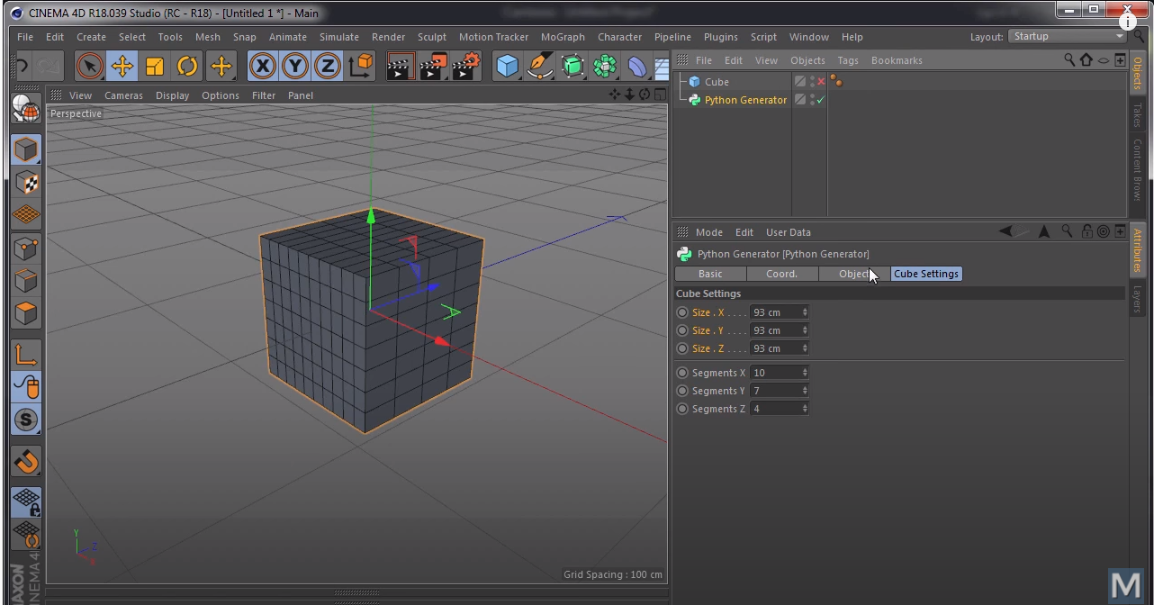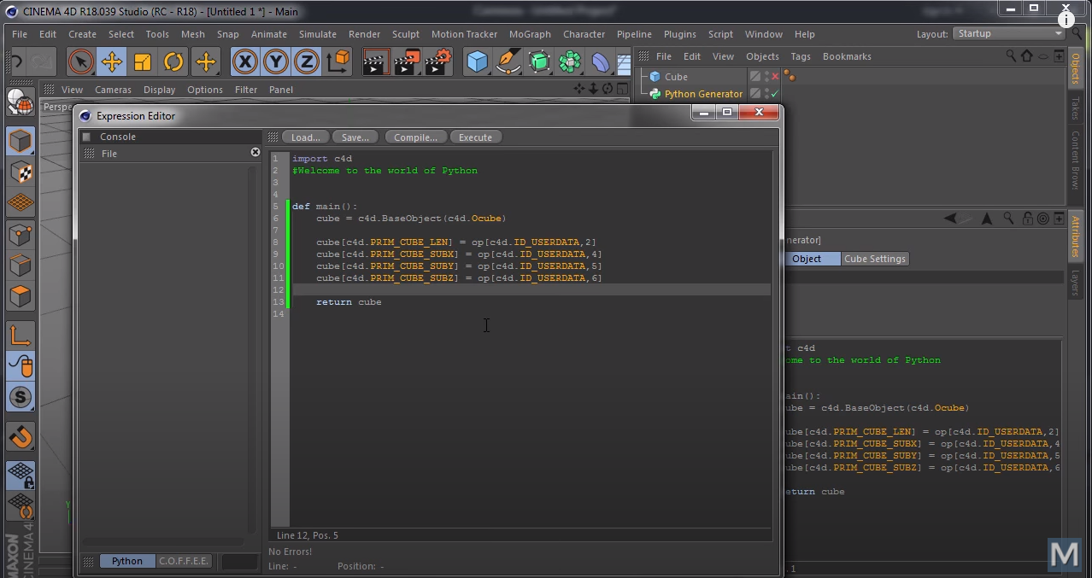

[ Picture 1, 2 – C4D program and using python example]

1. **Project Objective**

‘Design Your Code: designer helper’ goal is to lower the entry barrier of computer language so that designers and junior coders can easily access the development environment and designer do not concern about developing, they can only concentrate to designing.

1. When user drags and assembles blocks such as reservation word and external module which are already created, it will automatically change them to Python code.
2. Tips about Python code and current project. SNS function like Q&A board for sharing the information of how the others are using it and questions.
3. The function that changes the UI to React Code by drawing. Through these functions, developer can reduce the time for develop. Also, designer can easily communicate with developer more than before.
4. **User case**

* Mr. A who graduated the Visual Media Major that just taught about making Visual Media got a job immediately. But the Job uses Python for the simple iteration contents to speed up the video-making process. Many people say that it is better to learn while doing work, but he was not interested in it so took a long time to study.

1. Designers or creators can focus only on the creations they are interested in and make better creations by shortening the learning period for code.
2. Although users don’t know about Python’s grammar, they can use Python’s various powerful functions.

* Designer B wants to see how his UI looks on a real device. However, it is embarrassing to ask a UI development because it can be cost a lot.

1. The UI created by the designer can be converted directly into a code so that it can run on the actual device.
2. Can deliver the UI as it is created by the designer.
3. **Development environment and implement**
   1. Development Environment

We will develop this program with web-base, there are few reasons.

* For easy access from everywhere.
* For reduce download – install troublesome work.
* For support SNS function.

And also, we have a plan to extend SNS function to Android / Swift Application, we will use React.js.

Front-end will be developed with React.js like above. Back-end SNS Function will be developed with Node.js because it has many libraries and it is easy to use. There is also an advantage that we already know the language. Python Module analysis and conversion to python language will be developed with Python3, because there is many text processing while analyzing Python module.

* 1. Implement Features
* Code Conversion (Python – Block)

Need to be implemented that can develop Python code with block-coding style.

1. Basic reserved word and Data structure block need to be selected.
2. Third-party module upload / select function.
3. Need to show Block Code`s Result.
4. Conversion with Block code to Python Code.
5. Block explanation function.

* SNS Feature (React + Node)

Basic Q&A notice board will be implemented.

1. Basic Login, Sign-in or proceed with anonymous function.
2. Basic write, revise, delete function with notice board.
3. Basic Commenting and comment revise / delete function.

* Code Conversion (GUI - React / React Native)

When user draw UI, need to convert to React code. But we will not implement event system.

1. Basic GUI Drawing Kit will be offered.
2. When drawing UI, project need to change it to React or React Native Code. (This will support only one language via 2.)
   1. Project Problems

* Code Conversion

There are very many features for coding style. Coding Style will combine naming style, indentation, or abstract levels. Coding Style will as close as Python regular library. Naming style will be opened to user, but project can automatically named.

* Non-developer (User who is not familiar with coding)

However, block coding is very easy only to developer. Non computer-major student / designers are hard to understand about function, class or data structure. For this, we will make tutorial for making function or coding with block. And also, project will automatically correct or make "Class" for who do not want to know and do not interested in. (Project will automatically correction.)

And also, if function is named with English, we will name function English as it is, but we will add comment for that function block or other block. We will use module`s comment for this function. We also think about hovering event for block-comment style.

* Interpreter Server Security

As we need to run Python conversed code at our server, that python code can attack or corrupt our python code running server (which can say Interpreter Server). This can be dangerous for our system, so we will use “Docker Container” to make virtual running system.

1. **Task Assignment / Project Schedule**
   1. Task Assignment

구동완

* Back-end – SNS function development.
* Some Front-end task will be shared.

김민지

* Front-end – SNS function development
* React GUI function development

최현준

* Python – Block, React GUI – Code conversion function development
* Python, React GUI function development.
  1. Task Schedule

|  |  |  |  |
| --- | --- | --- | --- |
| **week** | **Development Schedule** | | |
| 1 | Idea planning and preparation for presentation | | |
| 2 | Determining the project content and  Distributing detail roles - 1 | | |
| 3 | Language study and  Distributing detail roles - 2 | | |
| 4 | 최현준  Block coding Content Development | 김민지  Front-end  /SNS  Development | 구동완  Back –end  /SNS  Development |
| 5 |
| 6 |
| 7 |
| 8 | Functional Integration and Bug fixing  Second demo preparation | | |
| 9 | Functional Integration and Bug fixing | | |
| 10 | Development of additional React functions | | |
| 11 | Development of additional React functions | | |
| 12 | Development of additional React functions | | |
| 13 | Functional Integration and Bug fixing  Final Demo preparation | | |
| 14 | Final Demo | | |

1. **Summary**

Motivation

* to lower the entry barrier of computer language.
* designer do not concern about developing, they can only concentrate to designing.

Develop Contents

* Code Conversion (Block – Python)
* Code Conversion (Graphic – React)
* SNS Features

Develop Stack

* React.js
* Node.js
* Python3
* Docker